Grove - 3-Axis Digital Compass

Contents
[show]

Introduction
This 3-axis digital compass features a low field magnetic sensing multi-chip module HMC5883L, which provides up to 1° to 2° heading accuracy. HMC5883L consists of high-resolution HMC118X series magneto-resistive sensors, as well as Honeywell developed ASIC containing amplification, automatic degaussing strap drivers, offset cancellation and 12 bit ADC. With peripheral power management circuit added, this is an easy to use and reliable compass module for low cost compassing and magnetometry.
Model:SEN12753P
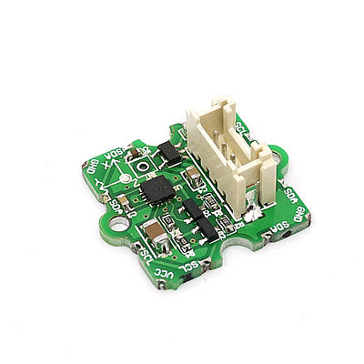

Features
- High resolution
- Easy to control I2C interface
- Compatible with either 3.3V or 5.0V development platform
- Max 116Hz output rate
- High heading accuracy

Applications Ideas
- Low cost compassing
- Magnetometry
- Pedestrian Navigation
- Hobby Auto Navigation
- Compassing support for mobile devices and portable computers (i.e connected via Blue-tooth or UART)

Specifications
Items | Conditions | Min | Norm | Max | Unit
VCC | - | 3.3 | 5.0 | 6.0 | Volts
Current Draw | Sleep Mode | - | 2.5 | - | μA
Current Draw | Idle Mode | - | 240 | - | μA
Current Draw | Measurement Mode (8Hz averaged) | - | 640 | - | μA
Resolution | - | - | 10 | - | milli-gauss
Linearity | ±2.0 gauss input range | - | 0.1 | - | ±% FS
Output Rate | - | - | 15 | 116 | HZ
Measurement Period | From receiving command to data ready | - | 8.3 | - | msec
Operating Temperature | Ambient | -30 | 85 | °C | milli-gauss
Storage Temperature | Ambient, unbiased | -40 | - | 125 | °C

Usage
This demo is going to show you how to read raw data, how to calibrate the data with your local magnetic declination angle and how to get heading angle.
First off, before any action you are going to take, you need to prepare a parameter you are going to use in your demo. That's your local magnetic declination.

You can find it out in degree via the magnetic declination webpage. For example, mine is -2°37’, which is -2.617 degree.
Then transfer it from degree to radians, and there you get the "declinationAngle". For example, in my case, declinationAngle = -2.617 / （2*π）= -0.0456752665 rad. Three significant figures are enough. So I would shorten it into -0.0456 rad. And this is the parameter you are going to replace the value of "declinationAngle" in the domo code with.

Now let's start to run your compass.
1. Plug the 3-axis compass into the I2C port of Grove - Base Shield.
2. Download the library file: Digital Compass Library. Unzip it into the libraries file of Arduino IDE by the path: ..\arduino-1.0.1\libraries.
3. Open the demo by the path:File -> Example ->Digital Compass ->HMC5883L_Example.
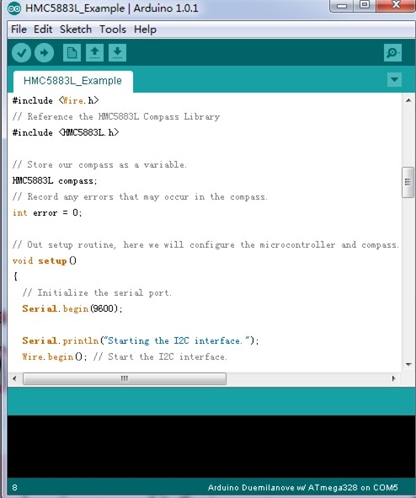

4. Replace the value of variable "declinitionAngle" with the one you've figured out already.
5. Upload the Code. Please click here if you do not know how to upload.
6. Check the output result by opening the serial monitor.
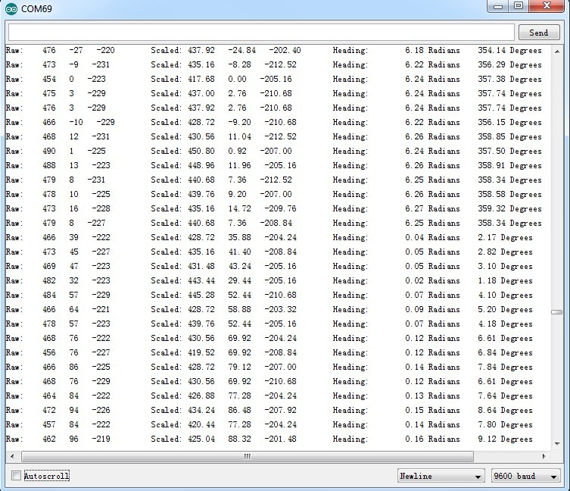

Reference
Below is a register map that might help you understand what you can get from this module.
There are totally 13 registers provided by HMC5883L. Out of three registers - Configuration register A, Configuration Register B and Mode Register decide the working mode of the device. The remaining registers are read only data output registers, status register and identification registers.
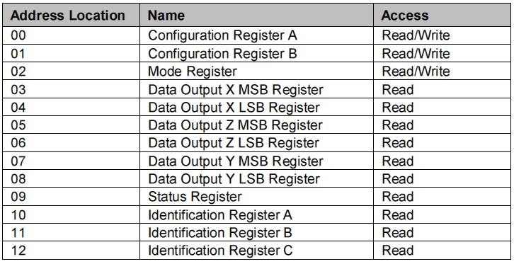
Table: HMC5883L Register Map
There are five operation modes of this module. They are Continuous Measurement Mode, Single Measurement Mode, Idle Mode, Sleep Mode and Off Mode. The module is defaultly set in the Continuous Measurement Mode. But you can get higher level of control authority by changing the setting of these registers. Find more in its datasheet.

Resources
- Grove-3-Axis Digital Compass Eagle File
- File:HMC5883.pdf
- file:Digital Compass Library

Support
If you have questions or other better design ideas, you can go to our forum or wish to discuss.

